Computer Network Lab


LAB WORK # 10

Submitted By
QASIM ALI (20P-0070)
Submitted to : Hurmat Hidayat
(INSTRUCTOR CS)

DEPARTMENT OF COMPUTER SCIENCE

FAST NATIONAL UNIVERSITY OF COMPUTER AND EMERGING SCIENCES, PESHAWAR

Session 2020-2024

HTTP analysis using Wireshark

- 1. Is your browser running HTTP version 1.0, 1.1, or 2?

Ans:
Open the Wireshark
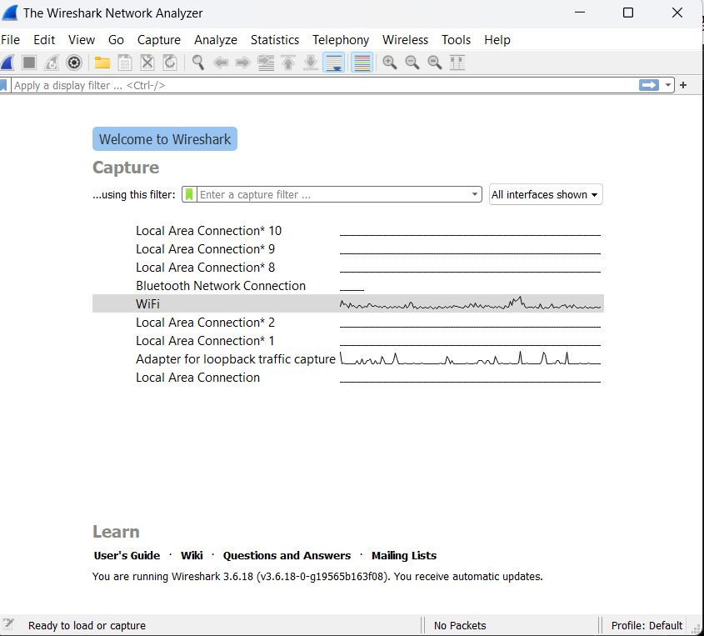

Start the Wireshark
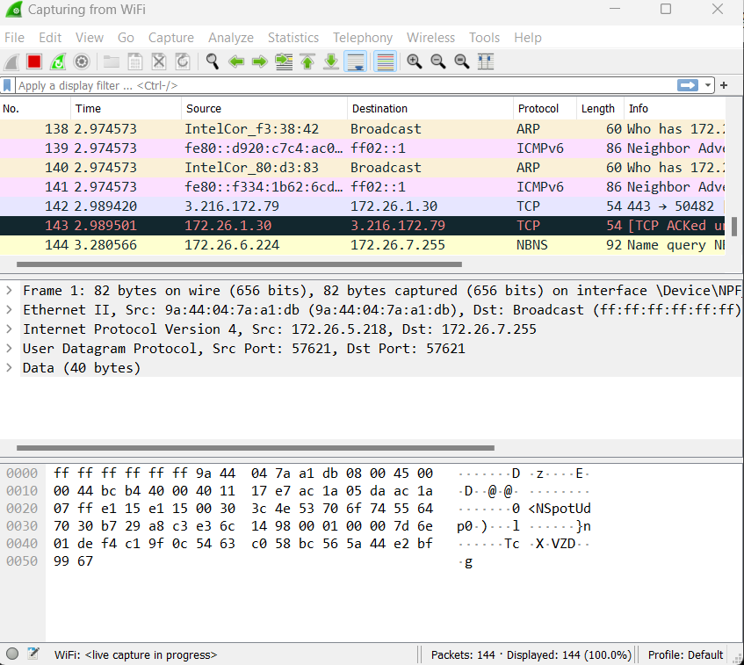

Select the Wi-Fi network :

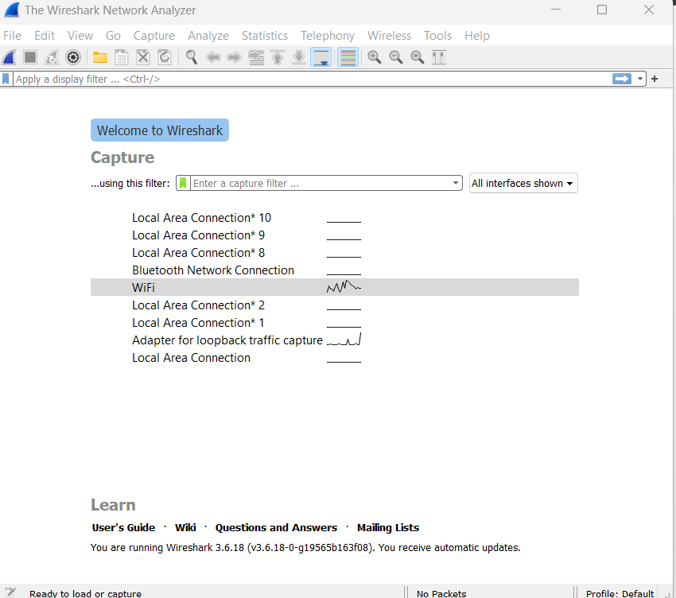

Select the wi-fi and double click on wi-fi
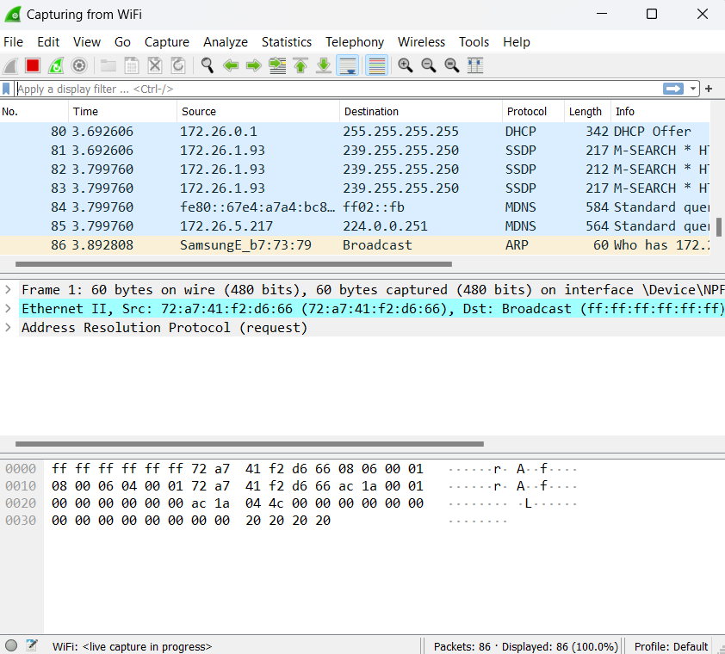

Now after start we want the http only and used the fiter the http packeg only those show in http in here . the http is empty because we can not add the code any .
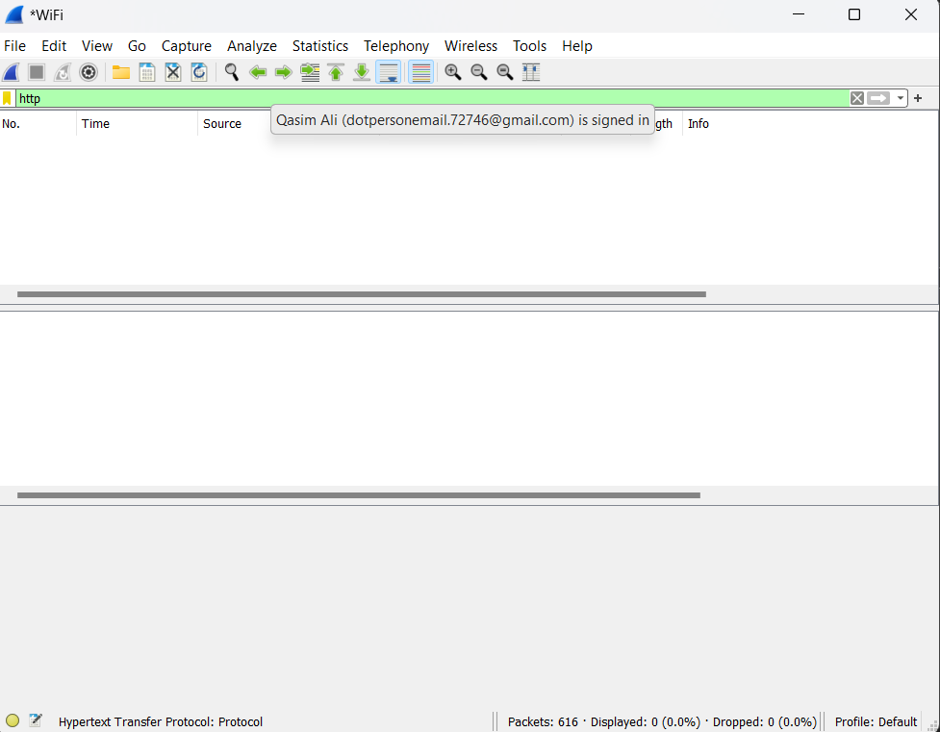

Request to dowloding the file

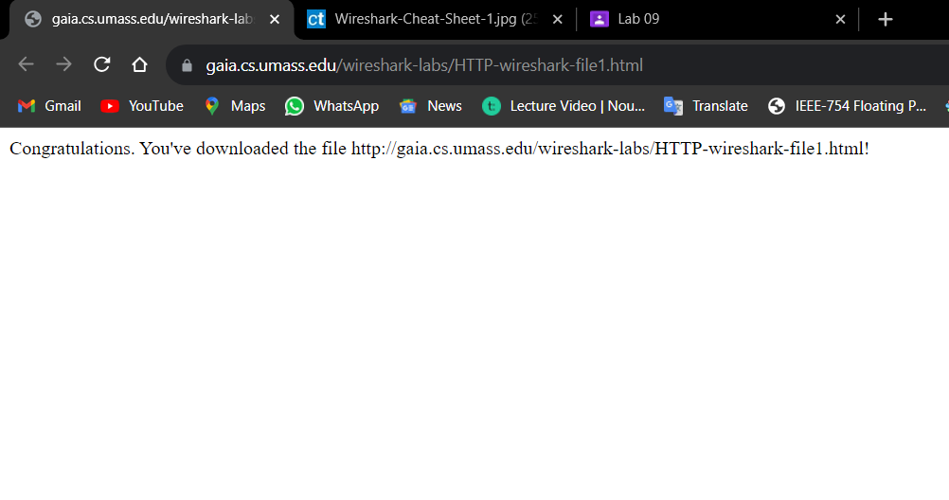
And after run this HTTP in web sever and open the wire shark and fiter the http only show.

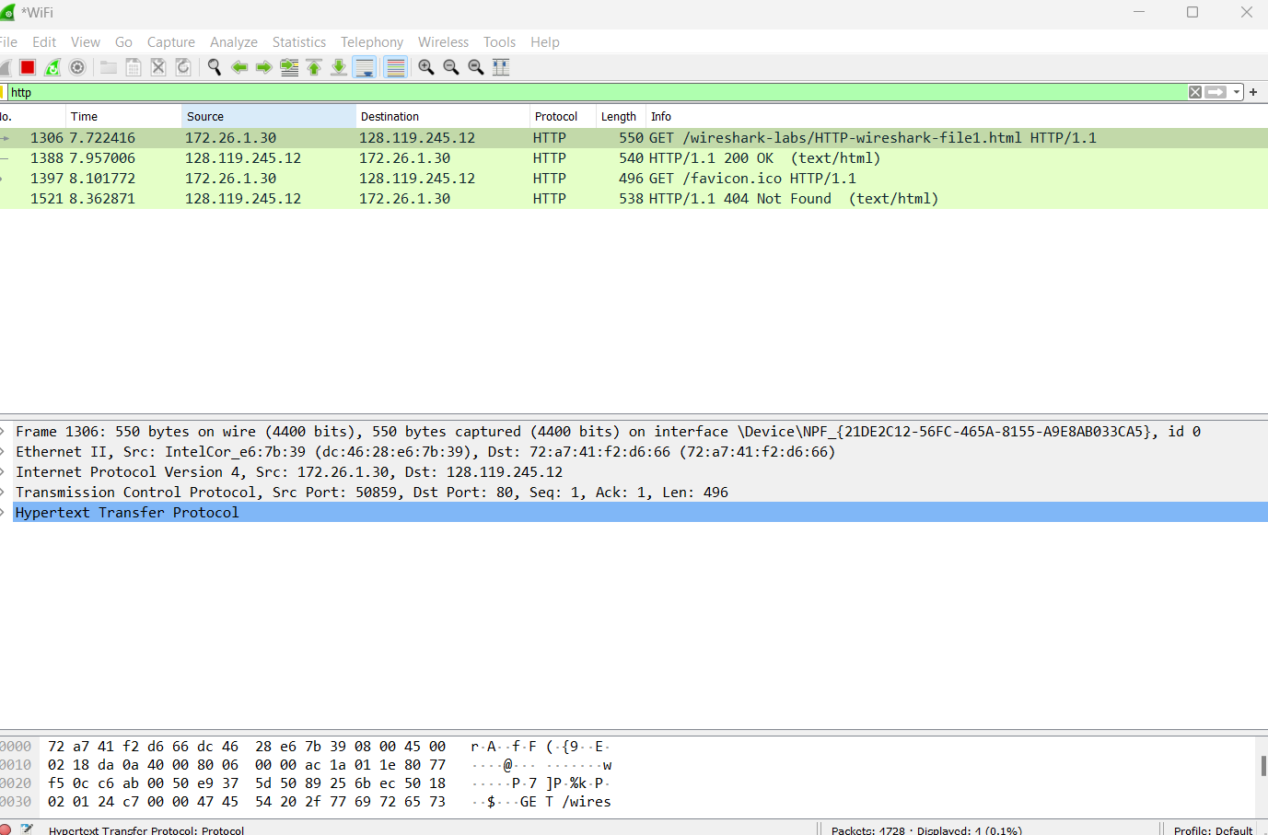

Both of them are version 1.1
(HTTP version information is listed in the item ‘Request Version’) 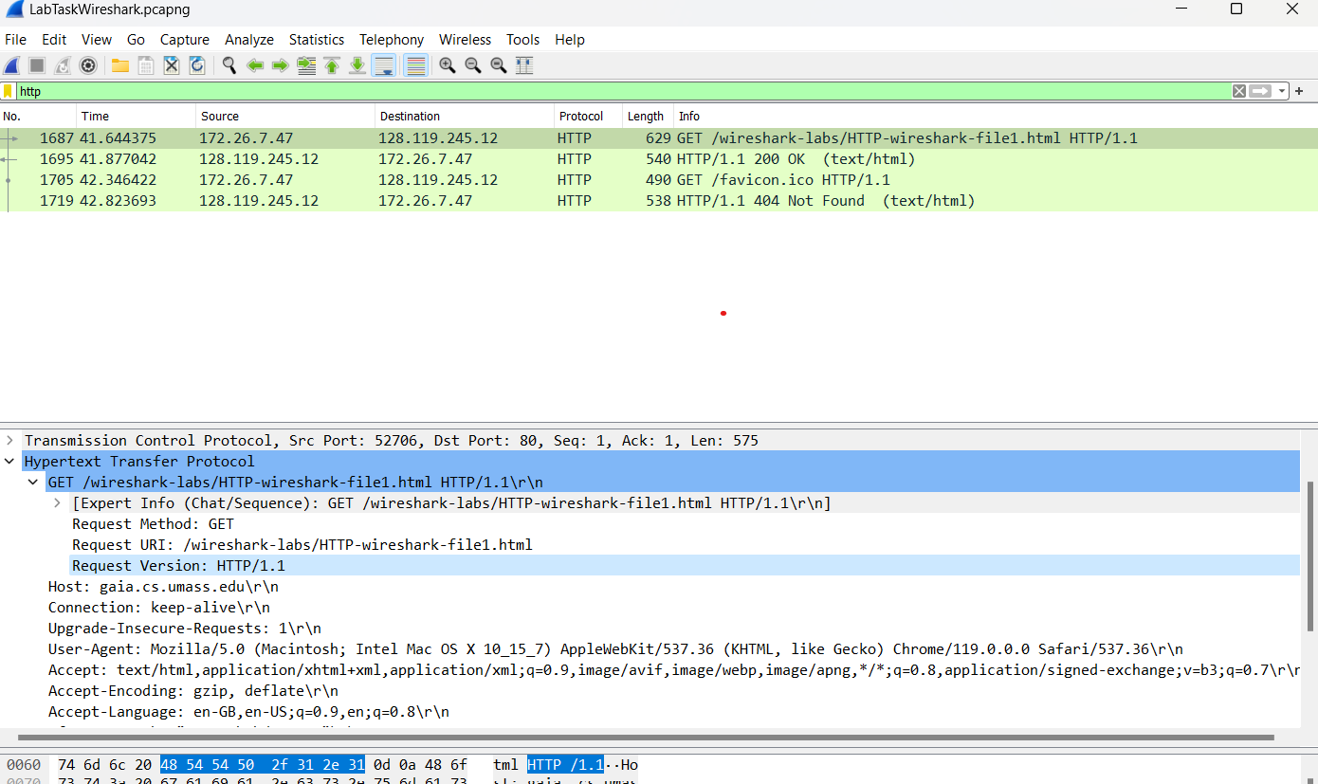

Q2. What version of HTTP is the server running?

Both of them are version 1.1
(HTTP version information is listed in the item ‘Request Version’)

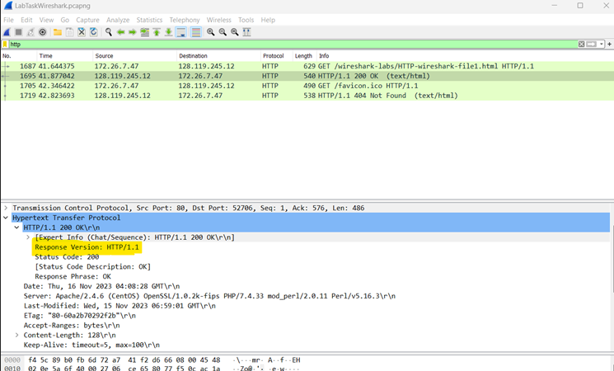

Q3: What languages (if any) does your browser indicate that it can accept to the server?
Ans: en-GB and en-US languages information is listed in the item ‘Accept-Language’ in the HTTP GET message.

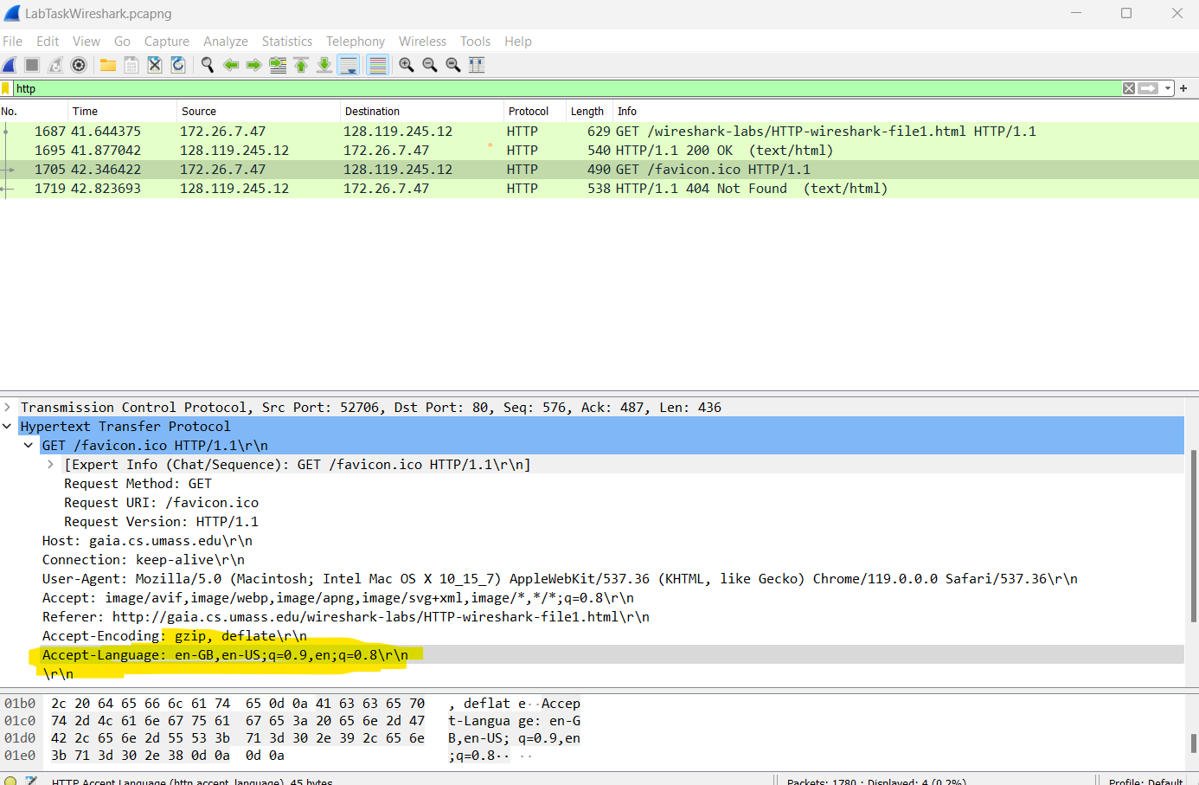

4. What is the IP address of your computer? What is the IP address of the gaia.cs.umass.edu server?
Ans: My computer: 172.26.7.47
gaia.cs.umass.edu: 128.119.245.12
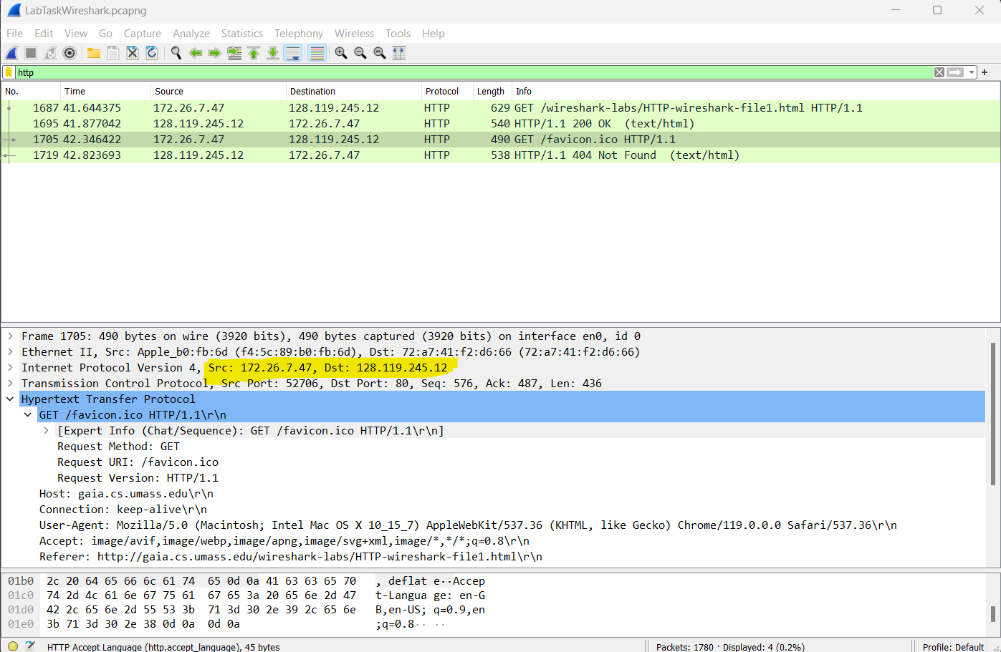
Q5: What is the status code returned from the server to your browser?
Ans: status code:200 -status code information is listed in the HTTP OK message
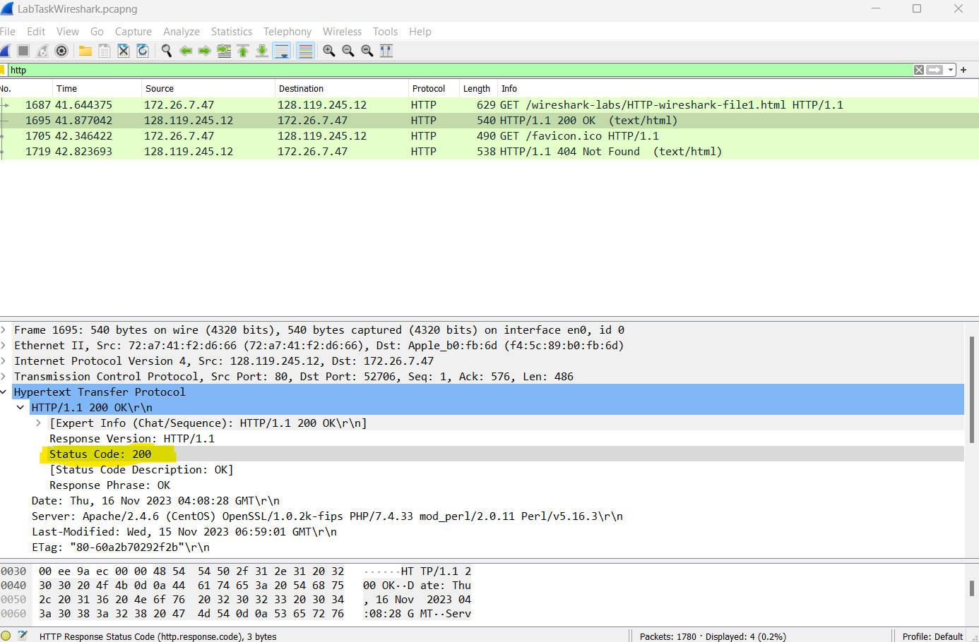

6. When was the HTML file that you are retrieving last modified at the server?
Ans: Wednesday, 15 NOV 2023
last modified information is listed in the item ‘Last-Modified’ in the HTTP OK message

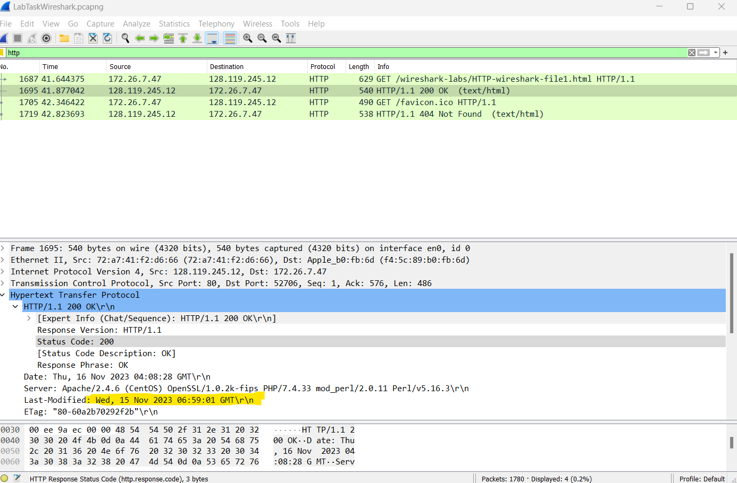

7. How many bytes of content are being returned to your browser?
Ans: Content length: 128
Content length information is listed in the item ‘Content-Length’ in the HTTP OK message

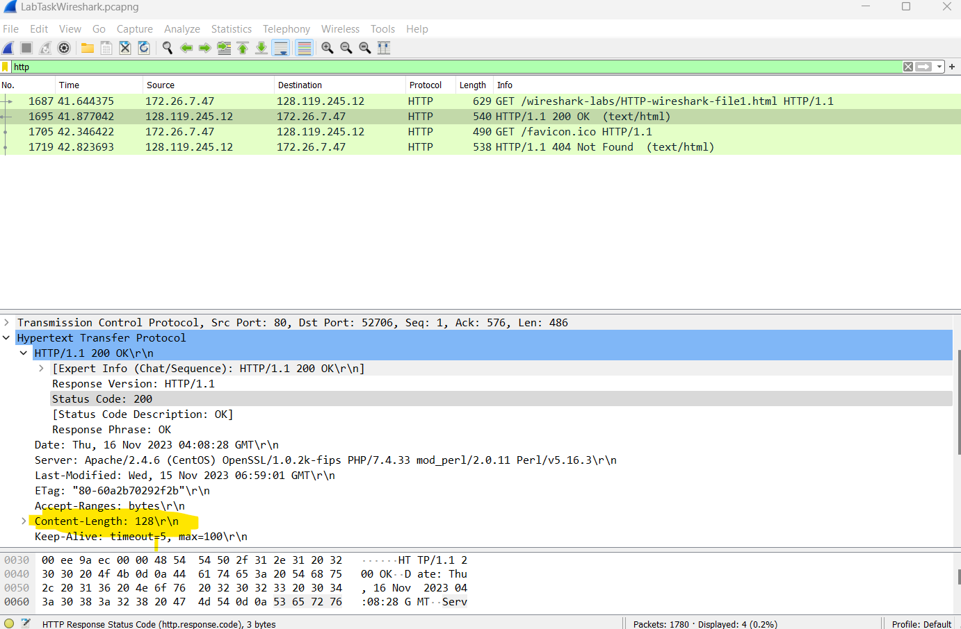

Task: Answer the following questions:
Q1. Inspect the contents of the first HTTP GET request from your browser to the server. Do you see an “IF-MODIFIED-SINCE” line in the HTTP GET?
Ans: We got a response that said ‘HTTP/1.1 304 Not Found’.
Status code: 304 Response phrase: NotModified.

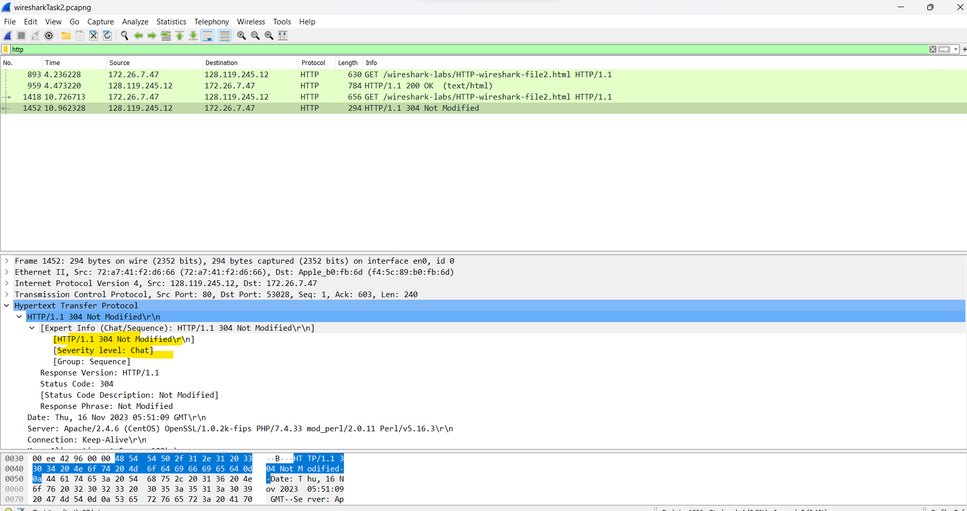

Q2- Inspect the contents of the server response. Did the server explicitly return the contents of the file? How can you tell?
Ans: The screenshot of first HTTP GET message:
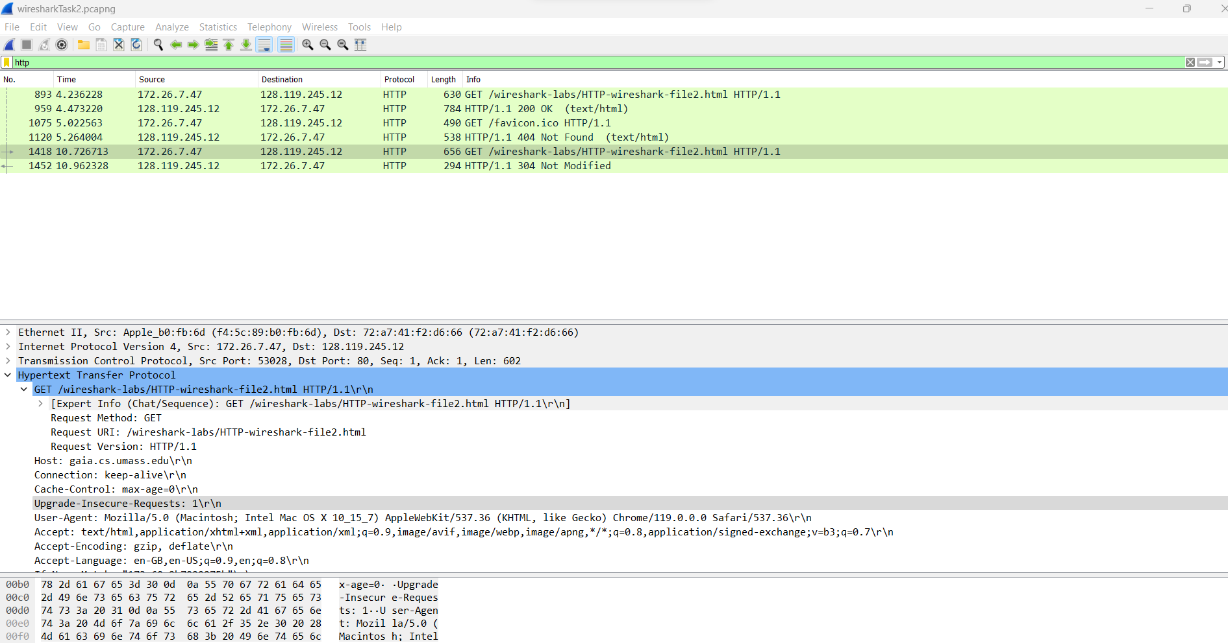

The screenshot of second HTTP GET message:
The data is found in sever;
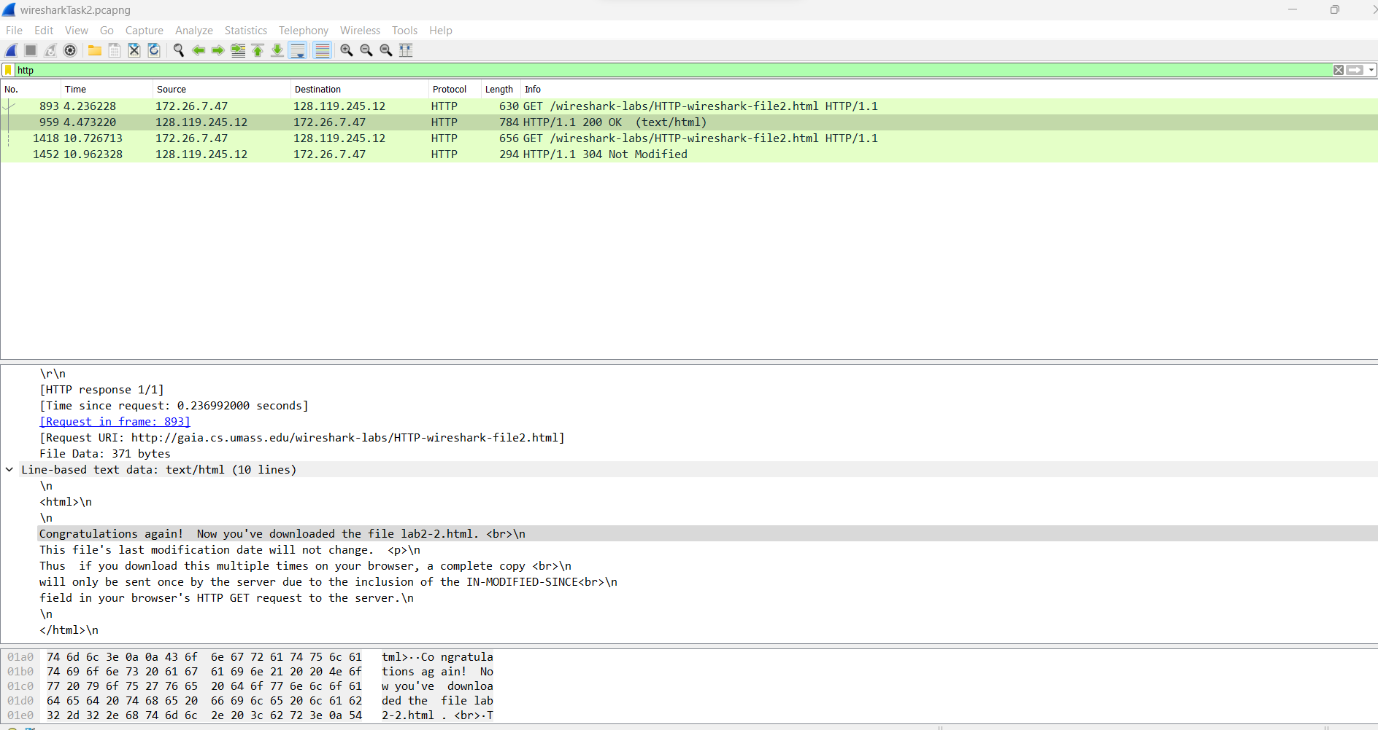

Q3: Now inspect the contents of the second HTTP GET request from your browser to the server. Do you see an “IF-MODIFIED-SINCE:” line in the HTTP GET ? If so, what information
follows the “IF-MODIFIED-SINCE:” header?

Ans: 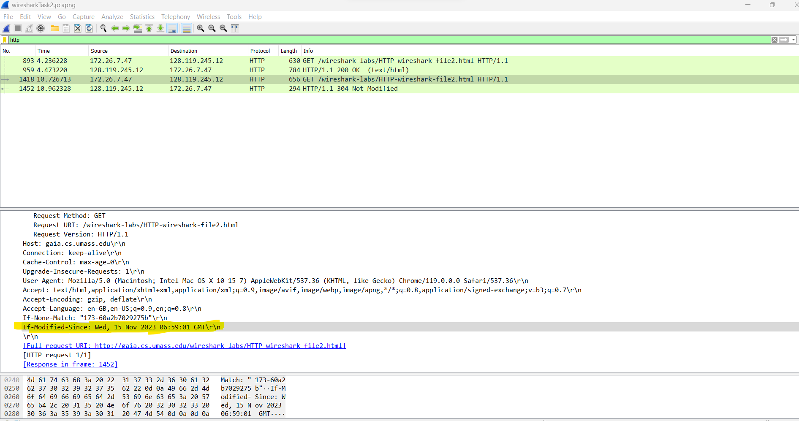

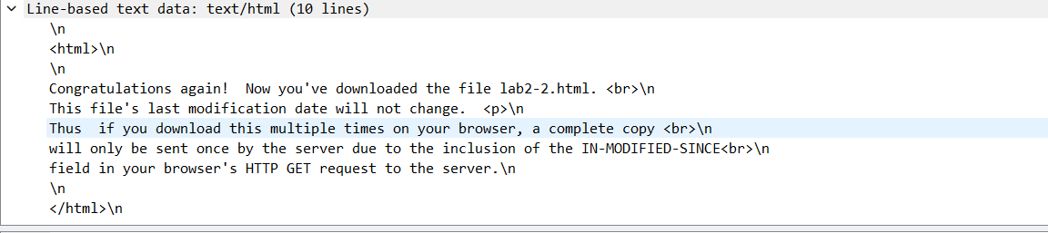

Q4: What is the HTTP status code and phrase returned from the server in response to this second HTTP GET? Did the server explicitly return the contents of the file? Explain.
Ans:
